Student worksheet

1.5 Meiosis forms gamete cells

Pages 12–13

Meiosis

1 What is a gamete cell?

|  |
| --- |
|  |

2 Fill in the blanks.

The process of meiosis produces , which fuse during the process of   
 to produce a , the first diploid cell of a new organism.

3 How many stages are in the process of meiosis and what are they called?

|  |
| --- |
|  |

4 What happens to the number of chromosomes in meiosis?

|  |
| --- |
|  |

5 Complete the table below by determining which type of cell division (mitosis or meiosis) occurs in each cell type.

|  |  |
| --- | --- |
| Cell type | Type of cell division |
| Bone cell |  |
| Ovum |  |
| Guard cell |  |
| Skin cell |  |
| Sperm cell |  |

6 If a goldfish’s intestinal cells each contain 94 chromosomes, how many would be present in the goldfish eggs produced by a female goldfish? Explain your answer.

|  |
| --- |
|  |
|  |
|  |
|  |

7 What does the ‘*n*’ and ‘2*n*’ represent in the diagram shown?

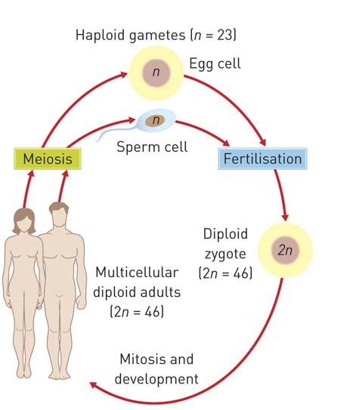

|  |
| --- |
|  |
|  |
|  |
|  |

8 Outline how four gamete cells form from a single diploid cell during the process of meiosis I and meiosis II.

|  |
| --- |
|  |
|  |
|  |
|  |

Extend your understanding

9 Suggest why meiosis is also referred to as reduction division.

|  |
| --- |
|  |
|  |
|  |
|  |